# ****CRM Application to Manage the Services Offered by EduConsultPro Institute****

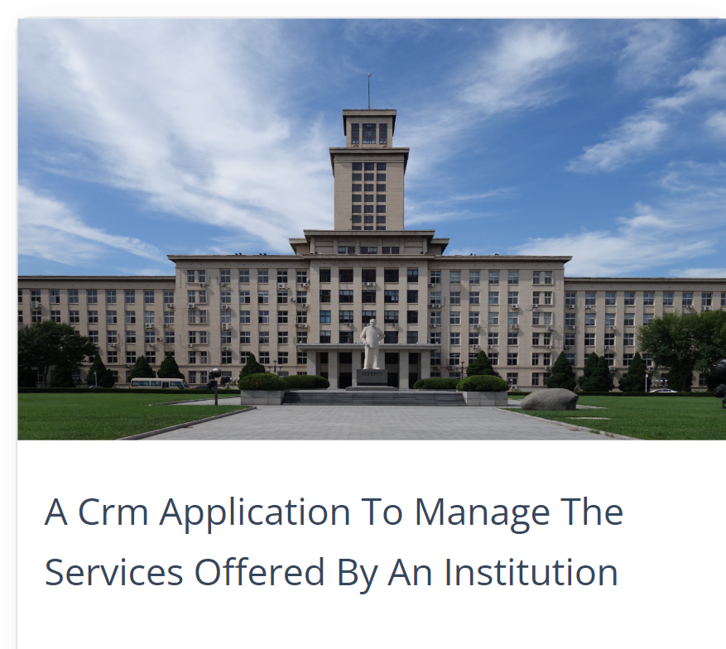

### ****Project Overview****

EduConsultPro Institute is a leading educational institution that wants to streamline its student admission and consulting services using Salesforce CRM. This CRM application aims to provide a seamless experience for prospective students and improve operational efficiency for the admissions staff. This document outlines the detailed steps to implement the CRM using Salesforce, covering the admission process, consulting services management, and case management.

### ****Prerequisites for the Project****

Before starting the project, certain prerequisites need to be fulfilled to ensure smooth implementation and functionality of the Salesforce CRM system for EduConsultPro Institute.

### ****1. Salesforce Licensing and Setup****

* **Salesforce Licensing**: Ensure that EduConsultPro has the necessary Salesforce licenses (e.g., Salesforce Enterprise or Unlimited edition) to support the CRM features required for this project.
* **Salesforce Administrator**: A Salesforce admin should be available to set up users, profiles, permission sets, and to perform system configurations.
* **Scratch Org/Developer Org**: If working on development or a pilot phase, set up a **Salesforce Developer Org** or **Scratch Org** to create and test custom objects, flows, and approval processes.

### ****2. Data Preparation and Cleaning****

* **Student and Application Data**: Collect and clean all necessary data (e.g., student details, academic records, consulting preferences) before importing it into Salesforce. Make sure it’s structured and formatted correctly for smooth integration.
* **Consulting and Immigration Case Data**: Prepare data related to consulting services and immigration cases that the CRM will need to manage.

### ****3. Defined Business Processes****

* **Admission Process**: Have a clear and detailed understanding of the current admission process, including application submission, review, approval, and follow-up communication with students.
* **Consulting Services Workflow**: Define how students request consulting services and how consultants will accept and manage these requests.
* **Immigration Case Management**: Define the steps involved in managing an immigration case and the roles responsible for handling different stages of the process.

### ****4. Salesforce Knowledge and Training****

* **Salesforce Admin Training**: Ensure that admins are familiar with creating custom objects, flows, approval processes, and Lightning app pages in Salesforce.
* **User Training**: Train the admissions team, consultants, and case managers to use the Salesforce CRM efficiently. This includes navigating through the app, viewing records, updating statuses, and handling approval processes.

### ****5. Email Templates and Automation Setup****

* **Email Alerts**: Prepare email templates in advance for different triggers such as application submission, appointment booking, consulting request approval/rejection, and immigration case updates.
* **Automation Setup**: Set up and test email automation for all necessary processes before going live, ensuring students and staff receive real-time notifications.

### ****6. Technical Requirements****

* **Integration with Website**: The CRM needs to be integrated with the institution's website or portal to capture admission applications and consulting requests.
* **Device Compatibility**: Ensure that all flows and the Lightning App page are optimized for use on both desktop and mobile devices to provide a seamless experience for students and staff.
* **System Requirements**: Ensure the institution has the necessary infrastructure in place to support Salesforce, including stable internet access and supported browsers.

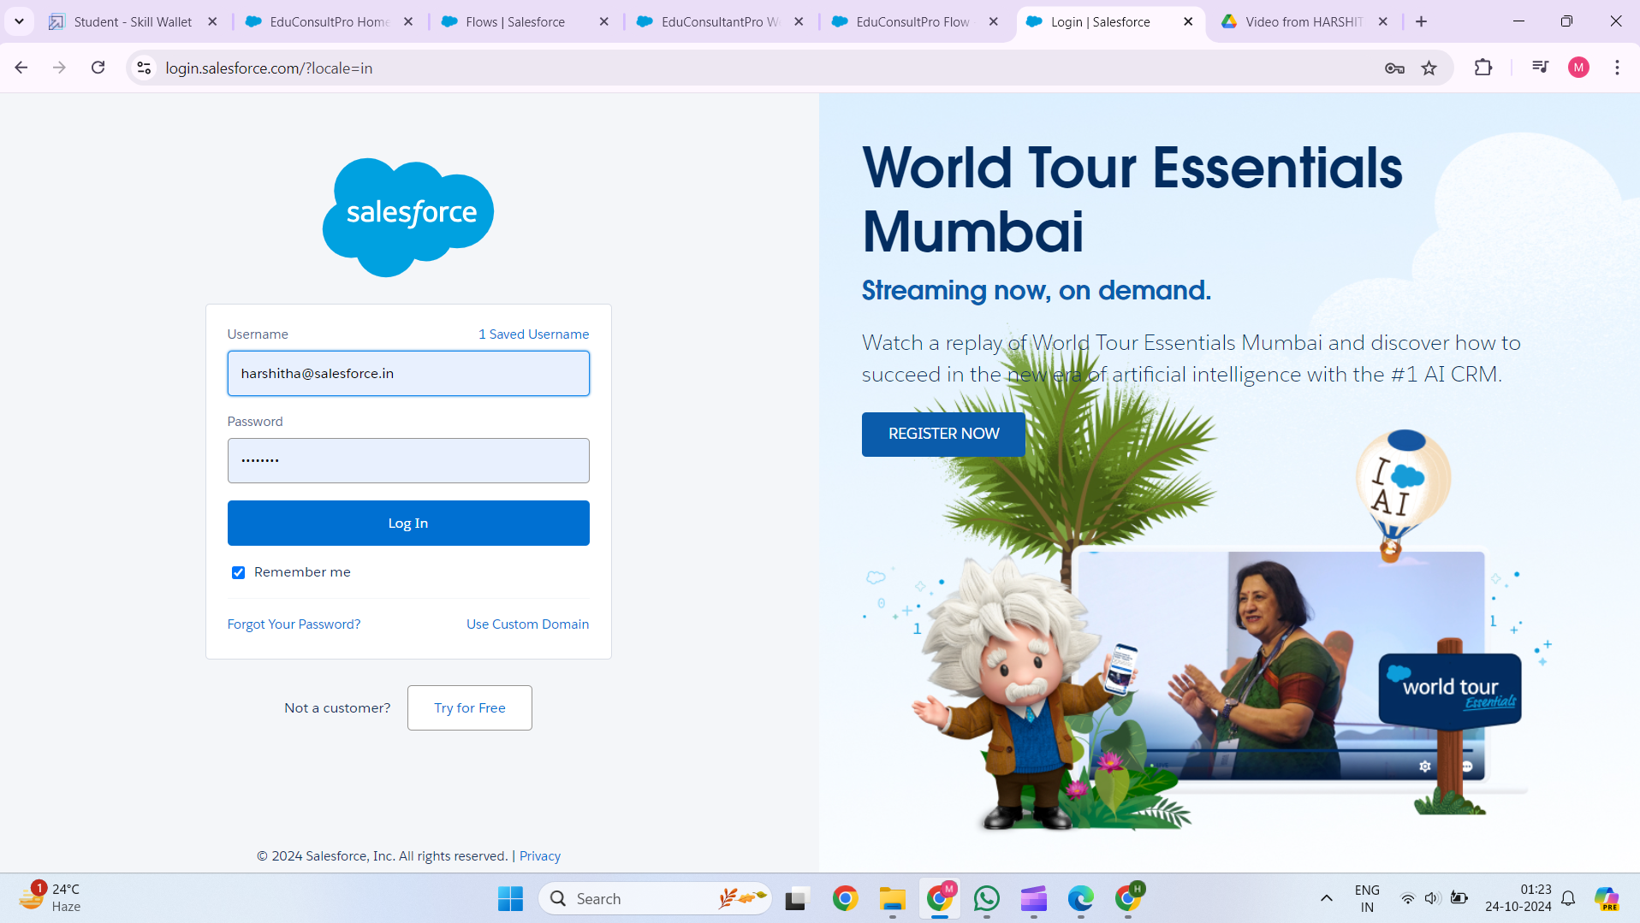

**PROCESS:-**

## ****1. Create Objects from Spreadsheet****

### ****Objective:****

Create custom Salesforce objects by importing data from a spreadsheet to capture student admission details, consulting requests, and immigration cases.

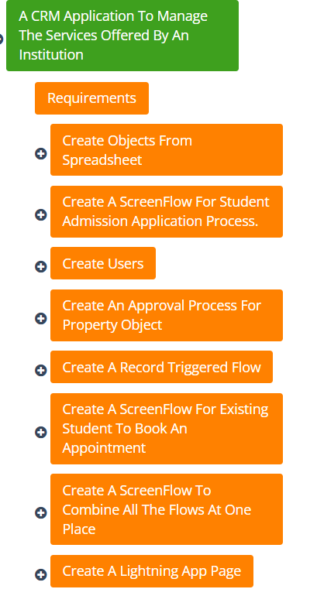

### ****Steps:****

**1.Prepare the Spreadsheet:**

* 1. Collect data such as personal details, academic history, qualification, consulting preferences, and immigration case details.
  2. Ensure the spreadsheet has appropriate columns and headers.

**2.Use Salesforce Data Import Wizard:**

* 1. Navigate to the **Data Import Wizard** in Salesforce.
  2. Upload the spreadsheet and map the columns to the appropriate fields for new or existing Salesforce objects.
  3. Create custom objects like **Admission Application**, **Consulting Request**, and **Immigration Case** if they don’t already exist.

**3.Verify Data Import:**

* 1. After import, check that all records have been created successfully.
  2. Ensure the data is stored correctly in the custom object

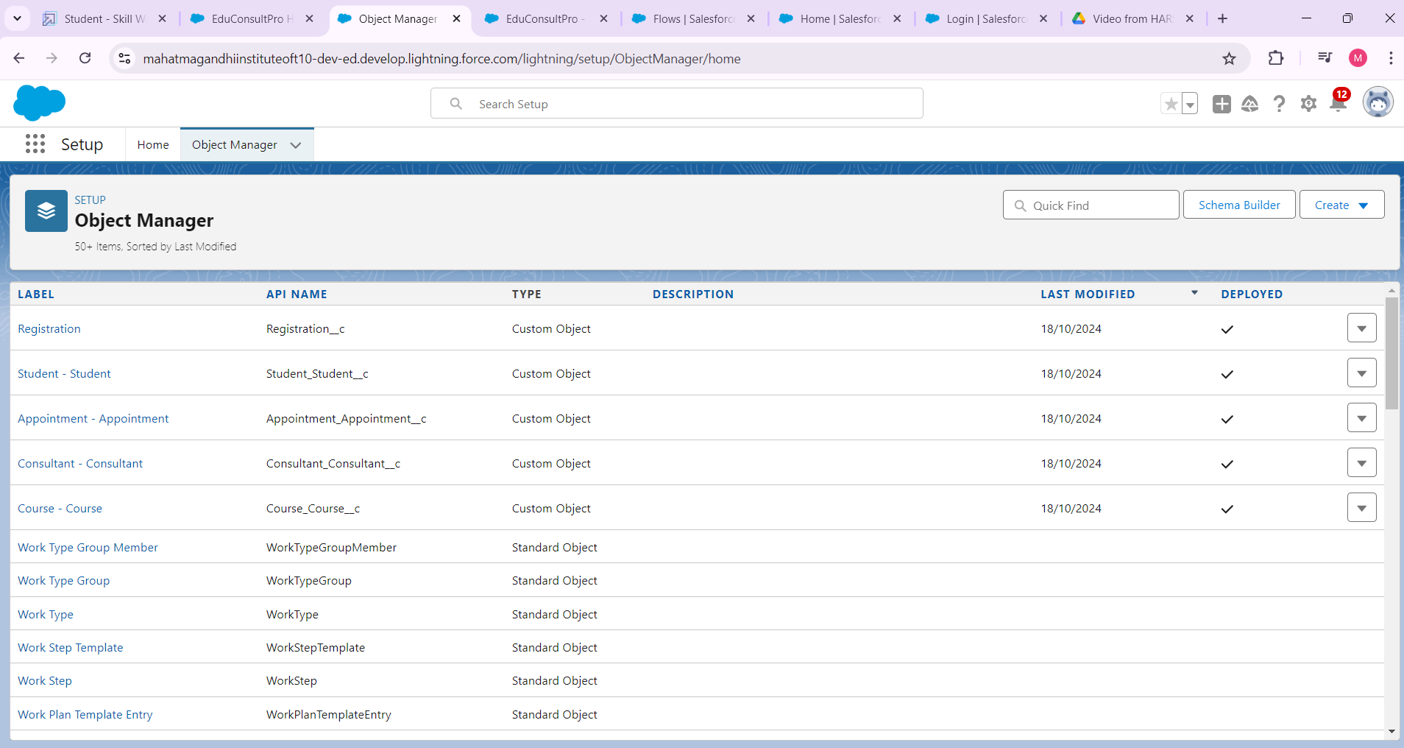

## ****2. Create a Screen Flow for Student Admission Application Process****

### ****Objective:****

Implement a **Screen Flow** that guides prospective students through an admission application form, capturing all necessary information.

### ****Steps:****

**1.Create New Flow:**

* 1. Go to **Setup** > **Process Automation** > **Flows**.
  2. Choose **Screen Flow** to design a guided process.

**2.Design the Flow:**

* 1. Add screens to collect data such as personal details, academic history, and qualifications.
  2. Use input components like text boxes, dropdowns, and date fields to capture the student’s information.

**3.Set Up Email Alerts:**

* 1. Configure email alerts to notify the student upon successful submission of the application.
  2. Use **Email Templates** for this purpose.

**4.Test the Flow:**

* 1. Ensure that the flow captures and stores the data correctly in the **Admission Application** object.
  2. Make sure the flow works seamlessly on different devices (desktop, mobile, etc.).

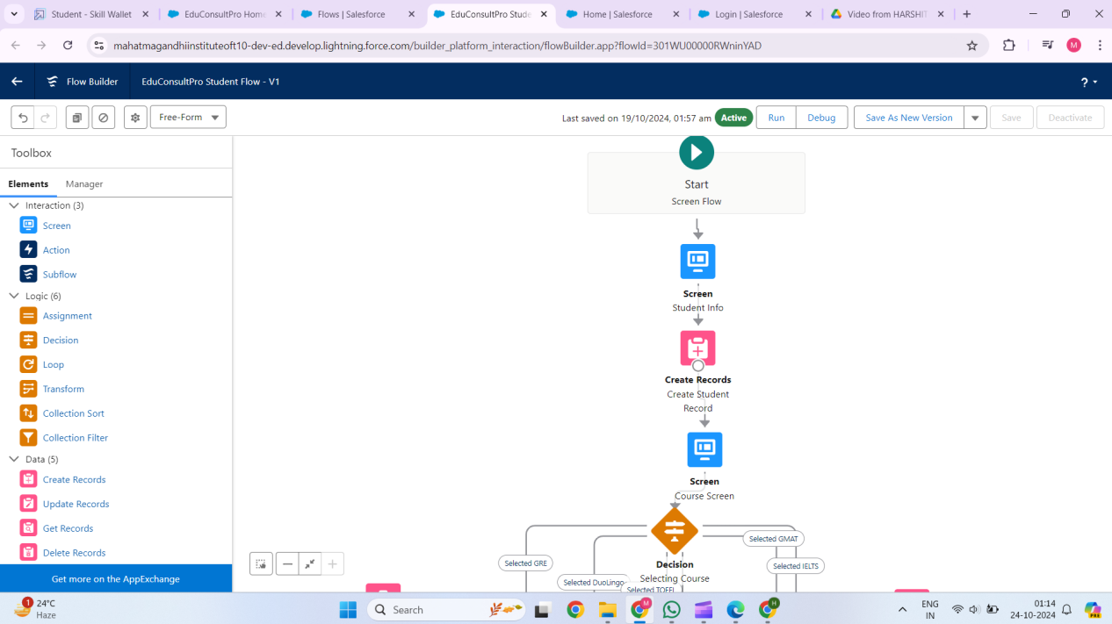

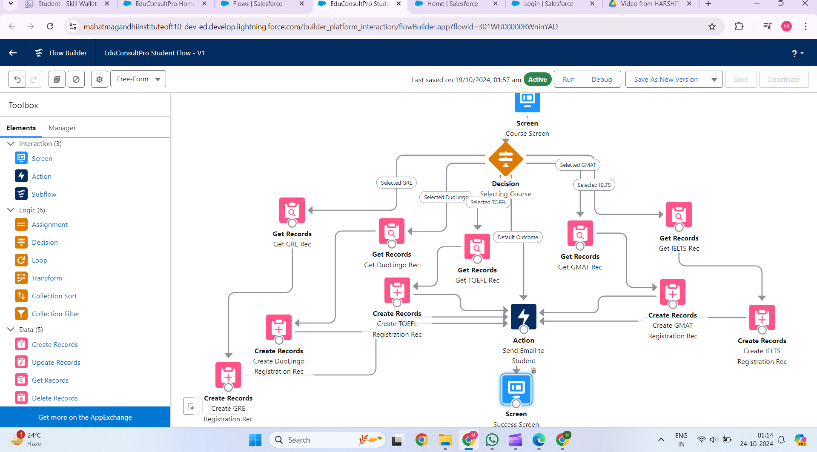

## ****3. Create Users****

### ****Objective:****

Set up users for the CRM system to access and manage the various objects and processes.

### ****Steps:****

**Define User Roles:**

* 1. Identify the roles involved, such as Admissions Officer, Consultant, Immigration Agent, and Student.

**Create New Users:**

* 1. Navigate to **Setup** > **Users** > **Add New Users**.
  2. Assign roles, profiles, and permission sets based on user responsibilities.

**Set User Permissions:**

* 1. Ensure appropriate access to the relevant objects (e.g., Admissions staff should have access to the **Admission Application** object).
  2. Use **Profile** and **Permission Sets** to manage access levels.

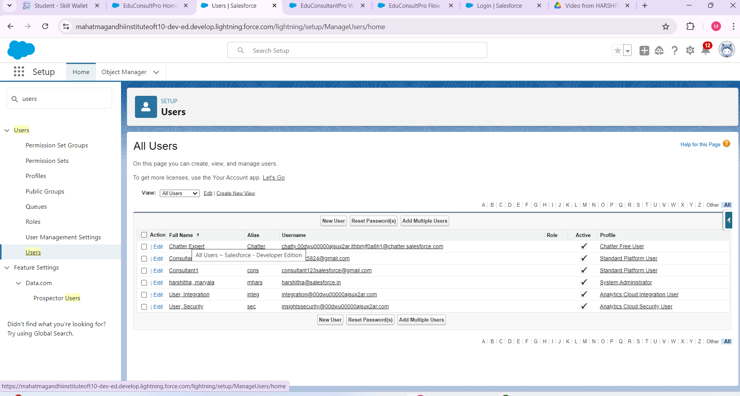

## ****4. Create an Approval Process for Property Object****

### ****Objective:****

Implement an approval process for consulting requests, where requests are reviewed, and an automated approval or rejection is sent.

### ****Steps:****

**Navigate to Approval Processes:**

* 1. Go to **Setup** > **Approval Processes**.
  2. Create a new approval process for the **Consulting Request** object.

**Define Entry Criteria:**

* 1. Set criteria to trigger the approval process (e.g., consulting requests above a certain threshold).

**Configure Approval Steps:**

* 1. Design the process where the request is reviewed by a consultant and then approved/rejected.

**Set Up Email Alerts:**

* 1. Create email notifications for both approval and rejection using **Email Templates**.
  2. Ensure students receive notifications about the status of their request.

**Test the Process:**

* 1. Test the approval process by submitting a few consulting requests and checking whether the approval or rejection is triggered.

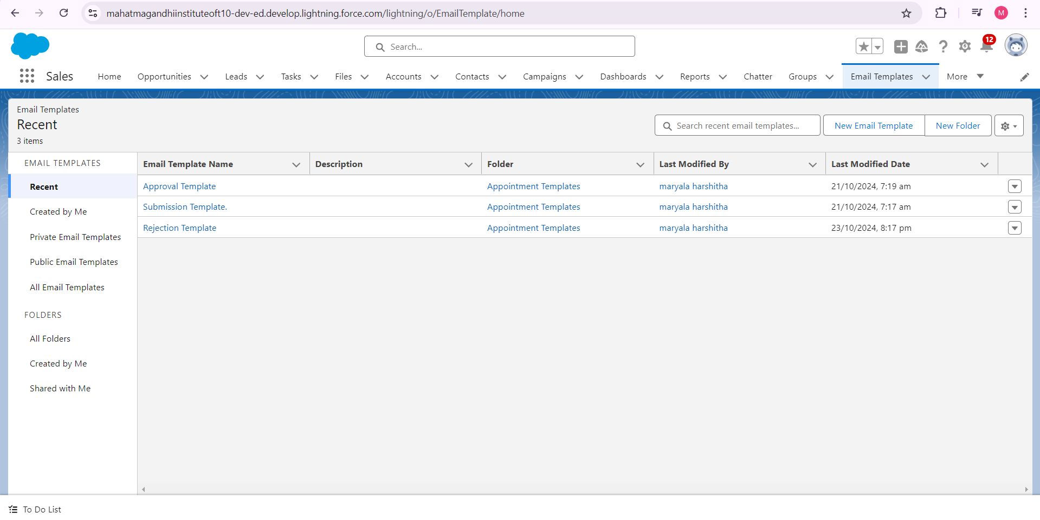

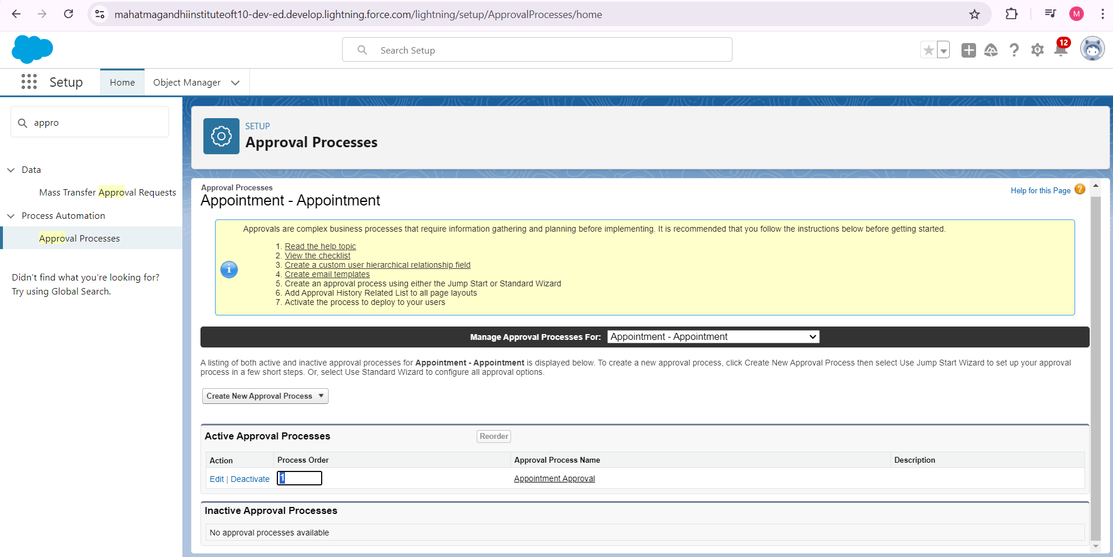

## ****5. Create a Record-Triggered Flow****

### ****Objective:****

Automate record-based processes such as updating fields or sending email notifications when certain conditions are met.

### ****Steps:****

**Create a New Flow:**

* 1. Navigate to **Flows** in Setup and select **Record-Triggered Flow**.

**Set the Trigger Conditions:**

* 1. Define the criteria for triggering the flow (e.g., when a new consulting request is submitted or an immigration case is created).

**Design Flow Actions:**

* 1. Add actions such as updating records, sending email alerts, or creating tasks.
  2. Ensure the flow is set to run when the specified conditions are met.

**Test the Flow:**

* 1. Run test cases to ensure the flow triggers correctly and performs the intended actions.

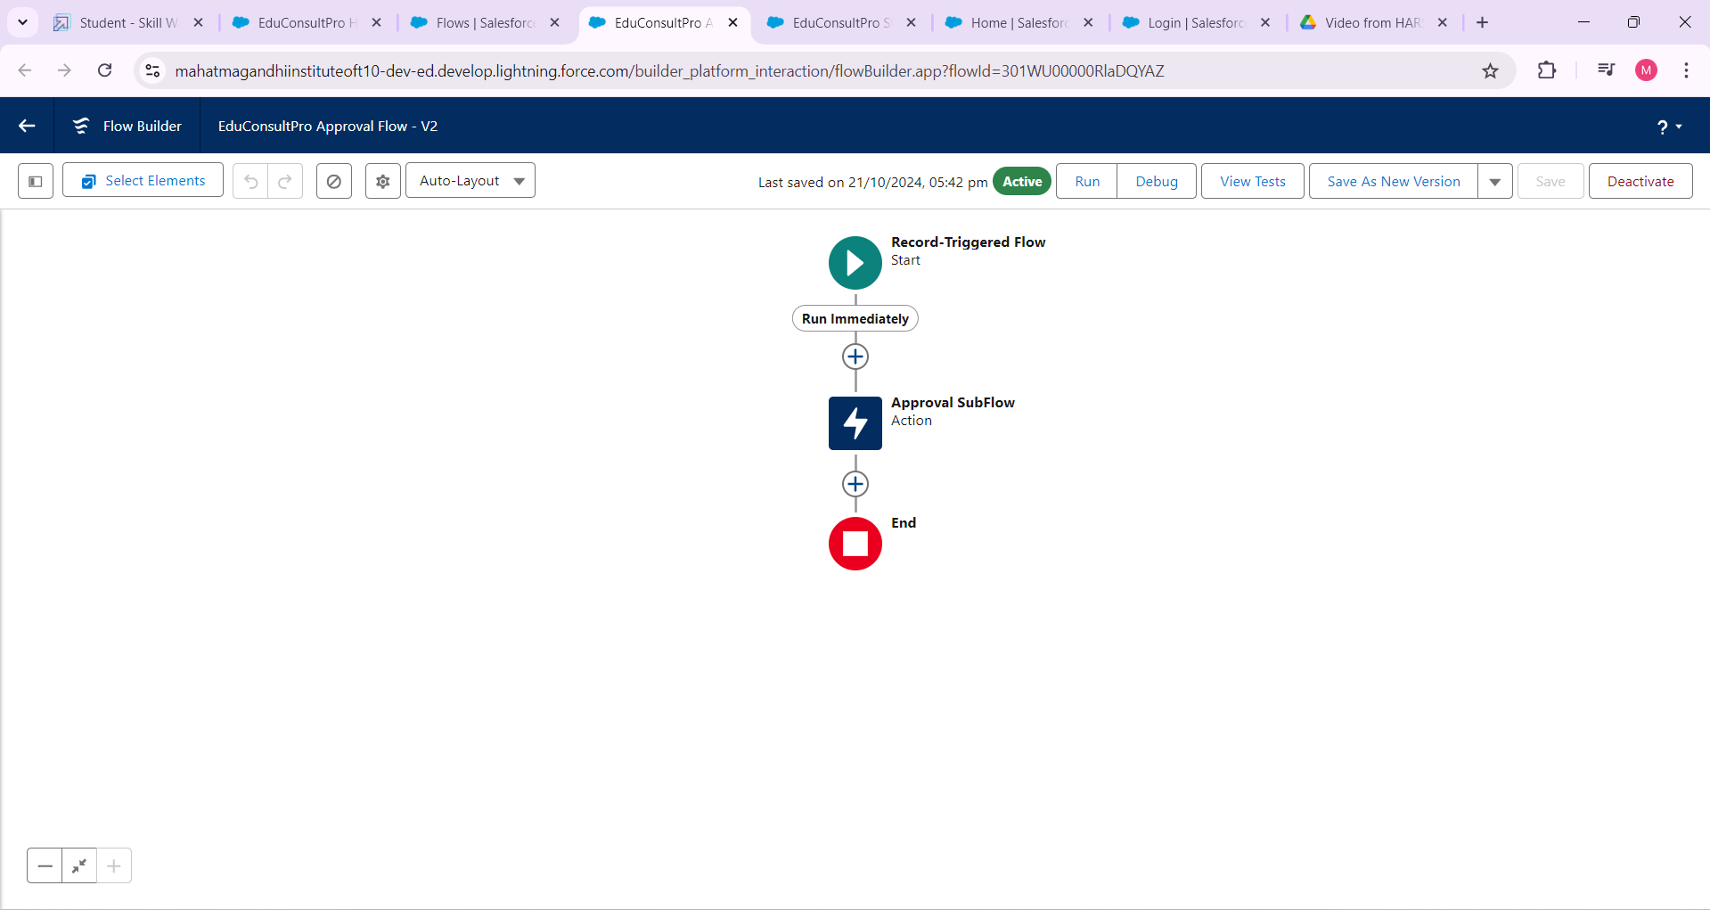

## ****Create a Screen Flow for Existing Students to Book an Appointment****

### ****Objective:****

Allow existing students to schedule consulting appointments through a Screen Flow.

### ****Steps:****

**Create New Screen Flow:**

* 1. Navigate to **Flows** and create a **Screen Flow** for appointment booking.

**Design the Flow:**

* 1. Use screens to collect appointment details like date, time, and purpose.
  2. Validate that students can only choose available time slots.

**Appointment Management:**

* 1. Store appointment details in the **Consulting Request** object.
  2. Set up automated emails to confirm the appointment.

**Test the Flow:**

* 1. Ensure students can book and manage their appointments through the flow.

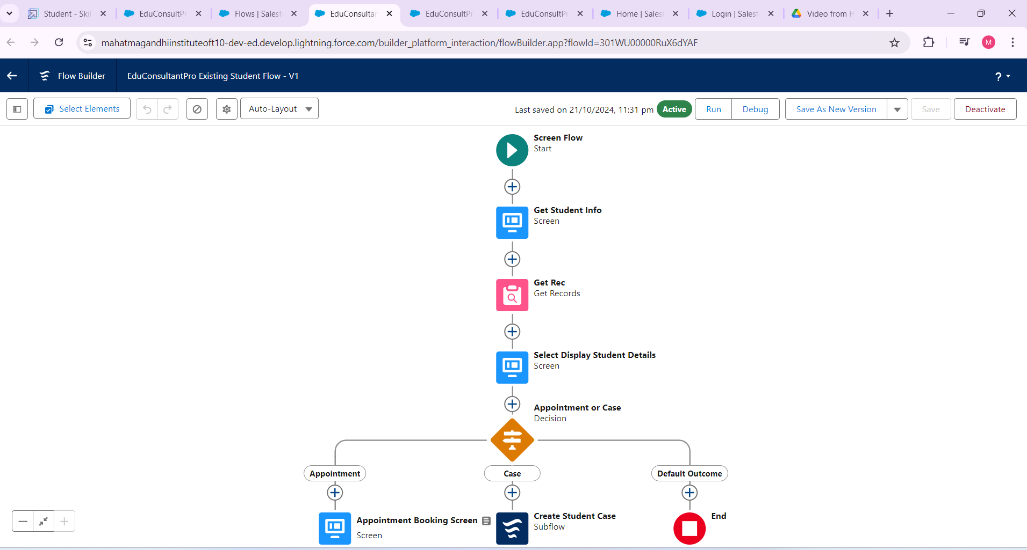

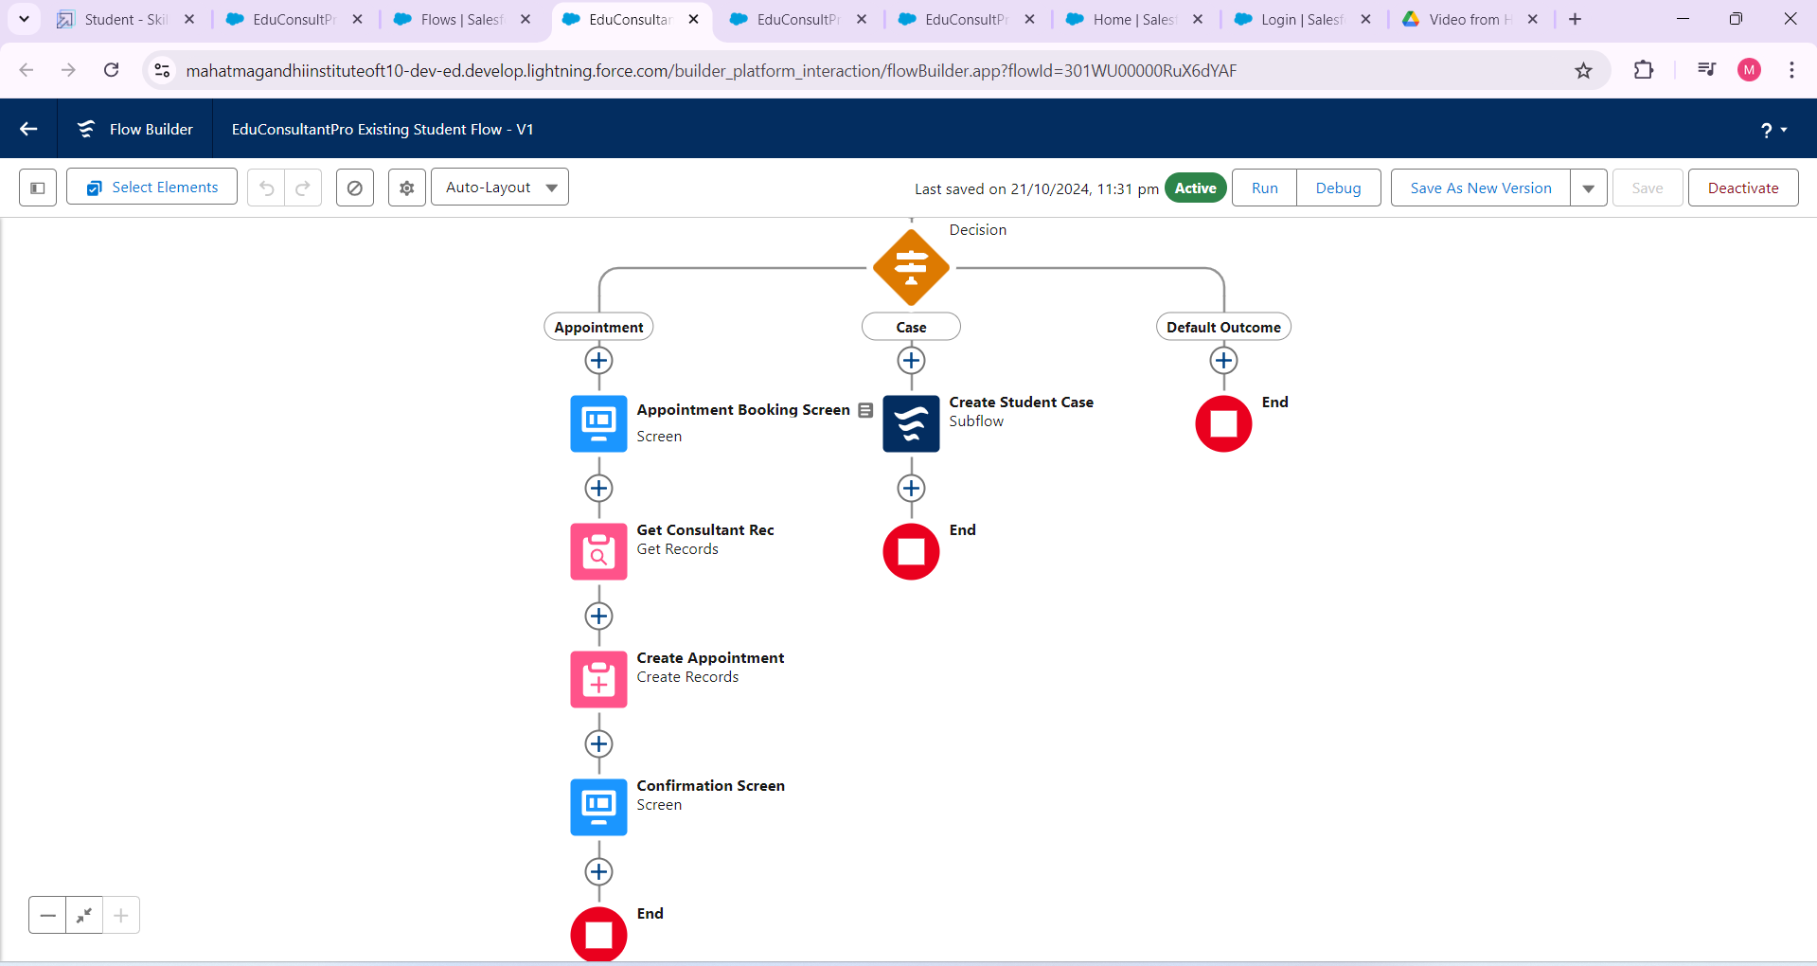

## ****7. Create a Screen Flow to Combine All Flows at One Place****

### ****Objective:****

Create a unified interface where all relevant flows (Admission Application, Appointment Booking) are accessible in one place.

### ****Steps:****

**Design Unified Flow:**

* 1. Create a new **Screen Flow** that includes buttons or links to access different processes (e.g., Admission Application, Appointment Booking).

**Link Existing Flows:**

* 1. Use **Subflows** to call the existing flows within this unified flow.
  2. Ensure that users can seamlessly navigate between different flows.

**Test the Unified Flow:**

* 1. Test to ensure all processes are working correctly and accessible from the unified flow.

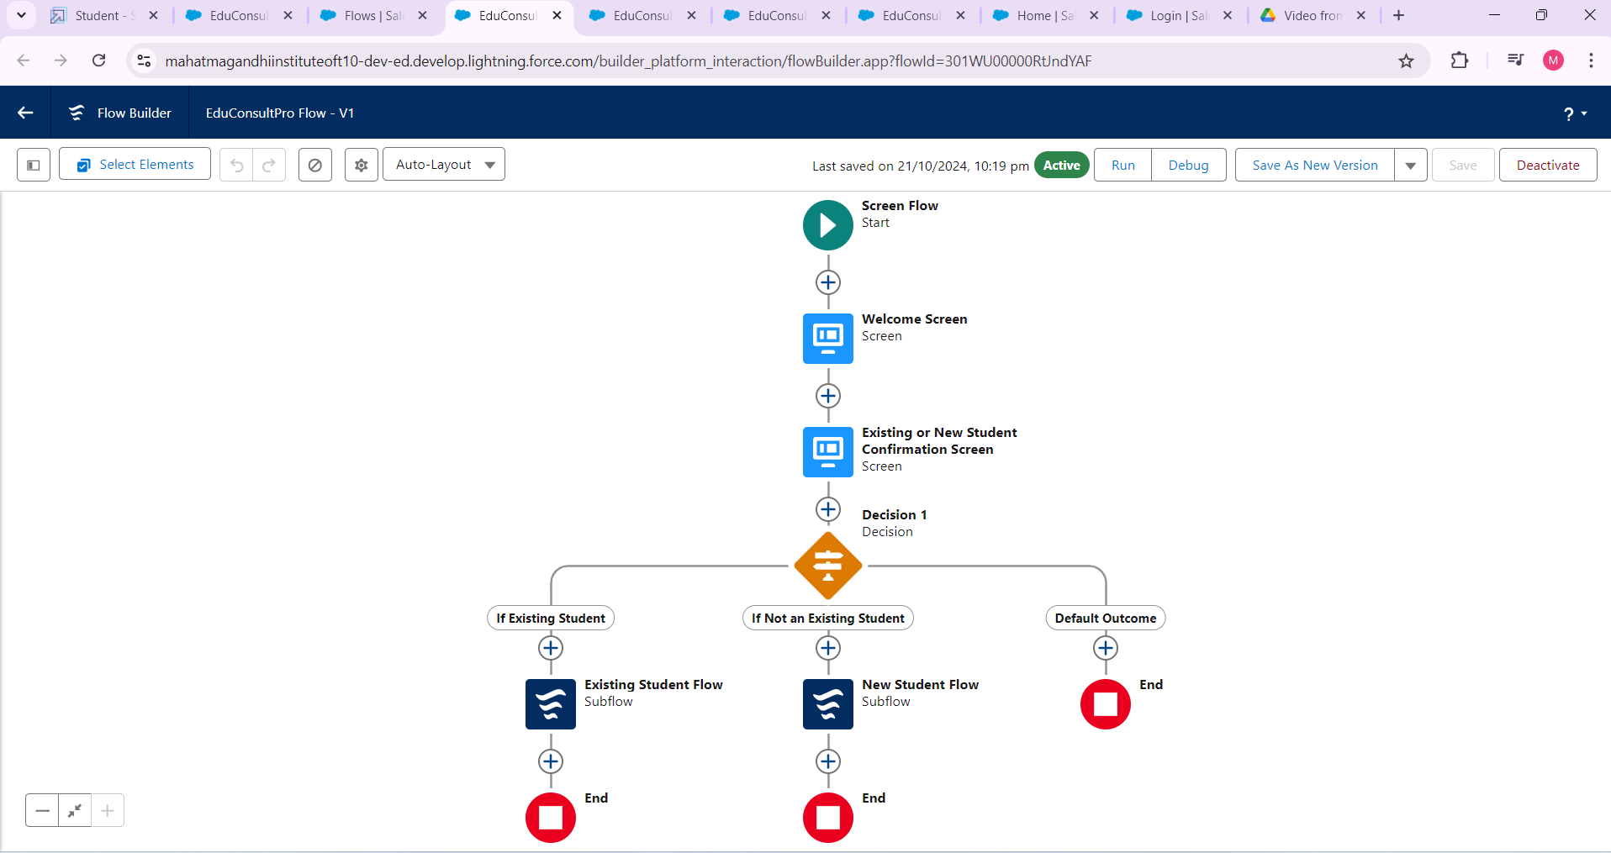

## ****8. Create a Lightning App Page****

### ****Objective:****

Build a Lightning App Page to display all flows and other necessary components in a user-friendly interface.

### ****Steps:****

**Create New Lightning App Page:**

* 1. Go to **Lightning App Builder** and create a new **App Page**.

**Add Components:**

* 1. Add components such as **Flow**, **Reports**, and **List Views** to the page.
  2. Include the unified flow you created earlier for easy navigation.

**Test the Lightning App Page:**

* 1. Ensure the page is functional and provides a seamless experience for admissions staff and students.

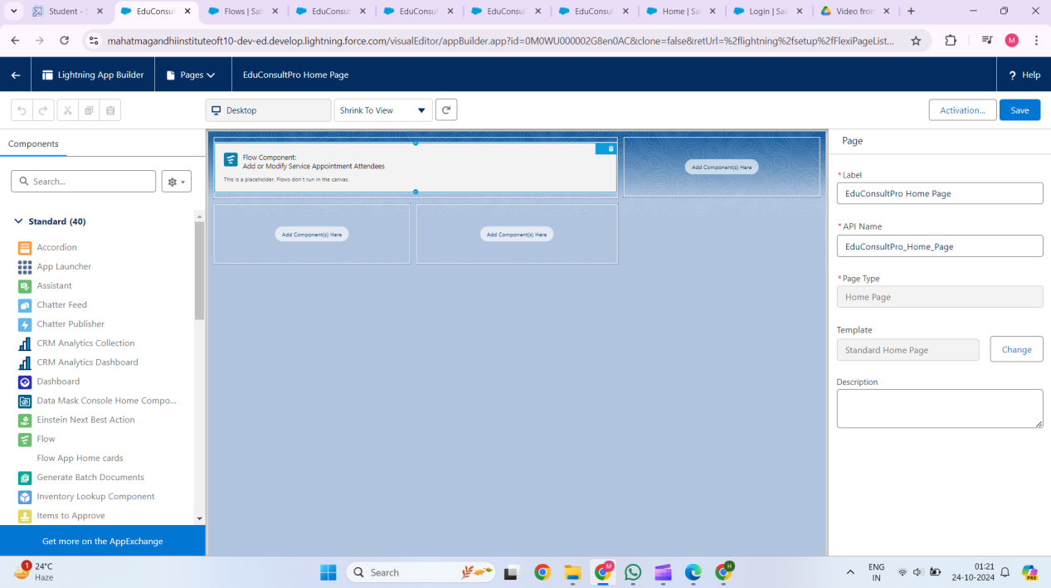

### ****Benefits and Advantages of the CRM Application for EduConsultPro Institute****



### ****1. Improved Efficiency in the Admission Process****

* **Automation of Manual Tasks**: The use of Salesforce CRM automates the admission process, from collecting application details to processing them, which saves time for the admissions staff.

### ****2. Enhanced Student Experience****

* **Self-Service Portal**: Prospective students can easily access and fill out their admission application forms through the institute's website, improving accessibility and convenience.

### ****3. Centralized Data and Case Management****

* **Single Source of Truth**: All admission applications, consulting requests, and immigration cases are stored within Salesforce, providing a centralized platform for managing student data.
* **Collaboration Features**: Built-in tools for document management and collaboration help staff work together efficiently on case management and consulting requests.

### ****4. Customized Workflows and Automation****

* **Approval Process Automation**: The CRM allows automated approval processes for consulting and property requests, reducing manual intervention and ensuring that the right people are notified for approvals.
* **Record-Triggered Flows**: Automating routine processes like sending follow-up emails or updating records when conditions are met ensures that no critical task is missed.

### ****5. Scalable and Flexible****

* **Scalability**: The Salesforce CRM system can easily handle a growing number of applications and consulting requests as EduConsultPro expands its programs and student base.
* **Customizable**: Salesforce is highly customizable, which means future processes or services (such as new courses or different types of consulting services) can be added to the system without overhauling the entire CRM.

### ****6. Improved Appointment and Consulting Services Management****

* **Appointment Tracking**: Consultants and students can easily view the status of appointments (scheduled, completed, or canceled), and the system tracks every update.
* **Consulting Request Management**: All requests are managed within the Salesforce platform, with notifications to advisors and consultants, making it easier for them to respond promptly.

### ****Conclusion****

Implementing a Salesforce CRM for EduConsultPro Institute offers numerous advantages, such as automating manual tasks, improving data centralization, and providing a better experience for both students and admissions staff. By meeting the necessary prerequisites, including system setup, user training, and data preparation, EduConsultPro can successfully implement a scalable and efficient CRM system that meets its current and future needs.

